NP Residency Precepting Policy and Procedures
COVID-19 Response – Telephonic or Face to Face Visits

In response to the COVID-19 health crisis, the NP Residency Program has made adjustments in its operations due to an increase in telehealth visits and remote employee work. This policy describes the procedures for precepting for the NP Residency Program in a range of different scenarios and defines the expectations of support and communication between preceptors and residents.

MEDICAL NP RESIDENCY PROGRAMS – FAMILY, ADULT-GERO, PEDIATRICS
Starting Monday, March 23rd NP Residency Precepting clinics will continue as scheduled. Due to range of circumstances including the resident and preceptor work locations and that patient visits may be conducted via telephone, this policy will outline the different procedures around preceptor support. For precepting being conducted virtually, the preceptor needs to be available for residents at all times for the duration of the assigned precepted session. This policy should be used as a guide but Residents and Preceptors should work together to figure out best modes of communicate for the smoothest and most efficient workflow possible.

Location of Resident: On-site Location of Preceptor: On-site
Visit types: Telephone or Face to Face Modes of communication: In person

Resident will conduct the patient visit in the exam room as outlined in the current policies. To discuss the case the Resident will communicate directly with the preceptor per the standard precepting policy. Preceptor will provide guidance and support for the Resident regarding the visit and then resident can return to the room to complete the encounter.

Location of Resident: On-site Location of Preceptor: Remote
Visit types: Telephone or Face to Face Modes of communication: Phone, Lync

Resident will conduct the patient visit in the exam room as outlined in the current policies whether patient is in person or via telephone. To discuss the case, the Resident will return to the pod to connect with the preceptor to discuss the case (phone or lync). Preceptor will provide guidance and support regarding the visit and then resident can return to the room to complete the encounter. Resident should connect with the preceptor at any time during the session by the agreed upon mode of communication to further discuss this or any other cases. If the resident is on site and requires in person support, they should reach out to one of the core team members on site at the time.

Location of Resident: Remote Location of Preceptor: Remote
Visit types: Telephone Modes of communication: Phone, Lync

Resident will conduct the patient visit via phone. To discuss the case during the visit the Resident will connect with the preceptor by lync – text, audio or video call as needed (see below for instructions). Resident should put the patient on hold on the phone while connecting with the preceptor (be sure to double check phone is muted). Preceptor will provide guidance and support for the Resident regarding the visit and then resident can return to the call to complete the encounter. Resident should connect with the preceptor at any time during the session by the agreed upon mode of communication to further discuss this or any other cases.
CONNECTING DURING PRECEPTING SESSION USING SKYPE (LYNC)

- Open a lync message with the contact you want to connect with.
- On the bottom you can choose to do a video or phone call to connect.
- If both residents and the preceptor want to connect as a group – click the add button on the top right to add another person to the conversation.
- To disconnect just hang up call. You can also mute your audio and turn off your video to pause the call.

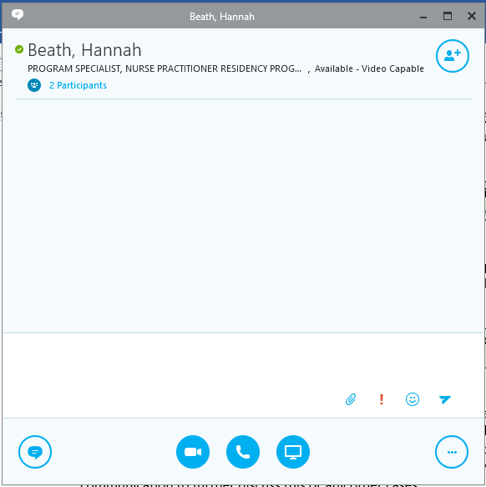
Add person to call
Audio
call
Video
call

https://support.office.com/en-us/article/make-and-receive-a-video-call-using-skype-for-business-abf62493-670f-4b0d-b2cf-fe03b49caf42

