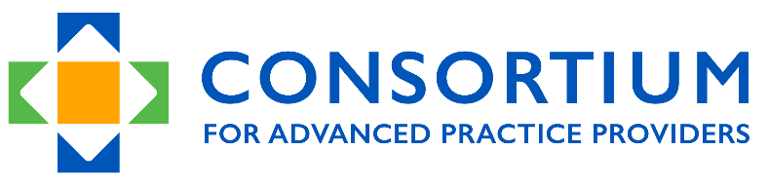

Site Visitor Training Course Overview
Spring 2024

The Consortium’s 2024 Site Visitor Training Course Overview: “A Day in the Life of a Site Visitor”

Course Information – The course is a hybrid web-based course with team-based activities that has a capstone activity of serving as an observer during an actual site visit.

The course consists of two 5-hour sessions. Each session has pre-work, small group work, discussions, and follow up. The premise of the course is ‘A Day in the Life of a Site Visitor’, a step by step trip through being a site visitor. Both sessions are required. After completing the two half-day training sessions, we will work with you to schedule and complete a site visit observation during the following 6-12 months.

The two half-day sessions which will be held on Saturday, April 6th and Saturday, May 4th from 12:00PM-5:00PM ET.

We believe that site visitor training is a true partnership of individuals with different expertise and experience that is shared in a peer-learning community. Our goal is that you are fully prepared to join a site visit as an active observer later in the year.

Going back to the idea of inspiring learning experiences, we share ownership of this course with each of you. We want it to be a challenging and profoundly worthwhile experience. The course is based on a flipped classroom, hybrid learning model that combines web-based, individual, and team-based learning. Consistent with our philosophy of accreditation, we intend for you to acquire a solid foundation of knowledge and skills while being open to new ideas, change and innovation.

Our goal is that each day’s preparatory work will spark in-depth discussions and explorations of accreditation philosophy, practice and process. Follow-up work will reaffirm the knowledge gained through discussion and experience. The course structure is very deliberately designed to include presentations, team-based work, group discussions, and use of simulation videos. There is a course resource center that offers information, best practices, examples of protocols, etc. We have integrated videos of simulated site visits, a mock self-study, and mock site visit team work throughout the course. Most importantly, we intend for this course to be a living embodiment of a responsive and dynamic learning community. As we move through each day of the course, we will ask for your feedback; and when we can improve the learning experience, we will. So let us know about your ideas and input, and we will do what we can to improve based on your input.

A quick overview of the site visitor time commitment/responsibilities (for an actual site visit, not the training course):
- Site visits last for 1.5 days on site plus the evening before (about 18 hours of work);
- Several preparatory conference calls (1 hour each);
- Reviewing Self-Study documents (3-4 hours);
- Joining in writing the site visitor report (2 hours as an observer — more as actual site visitor).

We ask that each site visitor participate in at least one site visit per year, if asked. After completing site visitor training (including serving as an observer), site visitors are offered a $1,200 stipend for each subsequent site visit.

Let me know if you have any questions. Our site visitors are the jewels in the Consortium’s crown. Site visitors are emblematic of all that we represent. They make our accreditation activities possible.

I look forward to walking through next steps with you!

Warm regards,

Kerry Bamrick, MBA
Executive Director

